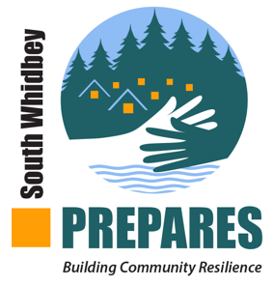 | Sample agenda for your first meeting

Getting ready:
- Invite folks to your event venue – time and location (plan on 90 minutes)
- Have refreshments available – perhaps have several people bring some. It’s an easy start to being neighborly
- Have name tags for everyone – first names are fine but use a pen large enough to read names across the room
- Arrange for someone to take notes
The Main Event
- Greet people at the door – welcome, I’m so glad you came
- Mingle around refreshments until everyone arrives
- Convene folks in a comfortable area where they can sit in a circle.
- Introduce yourself and thank people for coming
- Have an opening question(s) with which folks can introduce themselves. These are just ideas – select a question that is meaningful to your group. Go around the room, one person at a time, without interruption or cross talk
  - What potential disaster worries you?
  - Do you have personal experience or even a close friend who went through a disaster?
  - How long have you lived here?
  - What brought you to Whidbey?
  - What do you most love about living here?
- After everyone has spoken, explain why you want to do this preparedness work. Emphasize the fun involved, the advantages of knowing each other better. Explain the “cavalry isn’t coming”
- Observe reactions. Answer questions as best you can.
- Optional – share this NPR 6 minute segment, lessons learned from disasters around the world
- Optional – you can watch Scott’s talk at Anderson Island together. Scroll down to “sneak peak”
- Optional – pass out neighborhood-ready questions that invite folks to think about what could happen if disaster occurs
- Pass out Map Your Neighborhood brochures if you plan to use them
- Ask who wants to join you? It need not be everyone
- Ask how people want to play: perhaps just doing their own work, perhaps partnering with you to organize, perhaps someone is a researcher, ... there is lots of work to do
- Designate your next meeting date, time and where you will meet
- Thank everyone for coming
Shortly after:
- Send out notes from the meeting to everyone, the meeting reminder, a link to the South Whidbey web site, and know that you are on your way. Congratulations.

