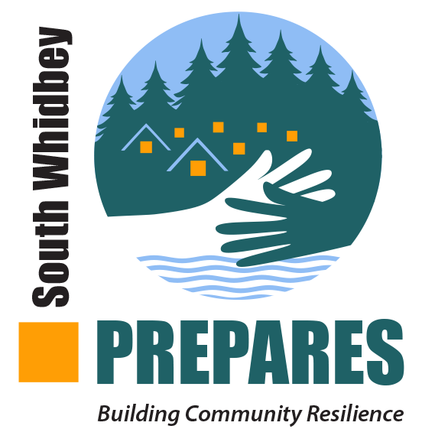

*Building Community Resilience*

Our web address

Greetings .... (neighbor’s name)

I have recently become inspired to serve as a neighborhood champion to organize our neighborhood for resilience and emergency preparedness. So I am here, hat in hand, asking that you consider joining me and _(how many)__ other neighborhood families in a conversation (where and when) about how we can organize ourselves

I am motivated to do this work because __(speak your own reasons or perhaps use these following words if they are close to your motives) I have learned that solo preparedness is probably a path to failure. In an emergency, there is no cavalry coming to save us. We can’t call 911 and expect a quick response if 8,000 households are making the same call. The good news is that by working together we can save ourselves.

Some of the particular questions that caught my attention were:

* In case of a major emergency, how long can I feed my family (and any people who might be visiting me and stranded here) without access to grocery stores?
* If there were a major fire, how would I escape with my family and pets? We cannot evacuate 15,000 people from the south end via the ferry!
* If I were stranded off island when an earthquake hit, who would take care of my children and animals?
* Who in my neighborhood would need extra assistance in a disaster?
* If my house were damaged by an earthquake in the middle of winter, how would I supply food, shelter and medical aid to my family?

We have a new initiative on island, partnering with our South Whidbey Fire/EMS and Island County Emergency Management. It’s called South Whidbey Prepares and it consists of us – people who care that everyone survives and even thrives in a major emergency, disaster, another pandemic, or even the inconvenience of a long-term power outage. We look at preparedness through a lens of love rather than fear. Adequately connected and prepared, we can be each other’s first responders until such time emergency services can get to us.

Please let me know your interest. It may be that you choose not to join us at this time. I certainly will not pressure you. But I hope I have at least piqued your curiosity so you will attend this meeting to learn more.

Sign your name, e-mail address and a phone #